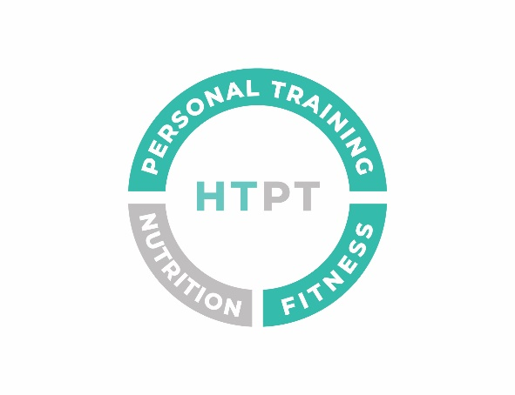P

**Physical Activity Readiness Questionnaire (PARQ)**

Signed………………………………………………………………………………….Name…………………………………………………………………Date…………………….

If you have answered No to all of the above questions or have presented a Doctor’s Note regarding one question then you have reasonable assurance of your present suitability for a graduated exercise programme.

**Please include any necessary Comments here**:

Yes/No

Yes/No

Yes/No

Yes/No

Yes/No

Yes/No

Yes/No

Yes/No

1. Do you suffer from chest pains when exercising?
2. Has a doctor ever stated that you have a heart condition and should only exercise

When supervised medically?

1. Have you developed chest pains in the past month?
2. Do you ever feel faint or dizzy when exercising and when not?
3. Do you have a bone or joint problem that could be aggravated by physical activity?
4. Are you taking any medication at the moment which the trainer should be made aware of?
5. Do you suffer from high/low blood pressure?
6. Are you pregnant? Or have been in the past 4 months?

This questionnaire is designed to outline any health related issues that may affect you during a training programme. Completing a PARQ is the first step to ensuring no injury or illness will be affected from training with the trainer, Hollie Thompson.

The PARQ is not designed to defer you from exercise but if you do circle YES in any questions I would ask that you seek medical consent before embarking on your new exercise programme. Please read each answer carefully and answer honestly.

**Name**…………………………………………………………………………………………………………………………………….. **D.O.B** ………………………………………..

**Address**………………………………………………………………………………………………………………………………….......................................................

**TEL**:……………………………………………………………………… **Email**……………………………………………………………………………………………………………

**Emergency Contact Details**…………………………………………………………………………………………………………………………………………………….......

……………………………………………………………………………………………………………………………………………………………………………………………………..